Kit for Exploring Most-cited Articles on AI Published in 2024 – Folder 4: Glossary of Epistemic Values (Readme)
Alan Liu (kit created 2025-08-05; rev. 2026-03-27; kit website; .zip file in Zenodo)

Folder 4 Overview
Using the data and tools in this kit, I harvested an glossary of epistemic values associated with, or circulating ambiently in, the discourse about AI in the corpora I refer to in my article, “AI Virtue: Epistemic Value and Generative Artificial Intelligence,” Modern Fiction Studies (forthcoming), as “WoS Core” and “WoS AHCI.” The glossary is a prototype or proof-of-concept because currently its less than 200 terms represent a partial harvesting of epistemic values that can always be added to and revised.

Folder 4Contents
Description | Primary Items  (Links go to materials on alanyliu.org website. For full kit, with all data, download the .zip file) | Tips for the General User
Readme (this file) | - readme_folder_4.docx
Glossary of Epistemic Values:  Glossary of epistemic values (positive and negative) mentioned in my two corpora, with frequency statistics and lists of ten nearest word-embedding neighbors of each word. (See folder 3 for the embedding models.) | Glossary in spreadsheet form:  - glossary-epistemic-virtues.xlsx  (PDF version) | The glossary spreadsheet is the most informative, but the web pages with interactive graphs are the most fun.  I used Anthropic’s Claude AI to code my “word-net” visualizations.  Disclaimer: The glossary is a prototype or proof-of-concept because currently its less than 200 terms represent a partial harvesting of epistemic values that can always be added to and revised.
Word-Net Graph Visualizations: Interactive word-net graph visualizations of the WoS Core and WoS AHCI words in the glossary. | Glossary visualized as interactive word-nets:  - core_word_net_graph.html  - ahci_word_net_graph.htm

Glossary Spreadsheet
The glossary spreadsheet I created contains both positive and negative epistemic value terms, and it tallies metrics for terms in separate columns for my WoS Core and WoS AHCI corpora. The spreadsheet also lists word-embedding nearest neighbor words for each corpus (see folder 3 in this kit for the embedding models.)
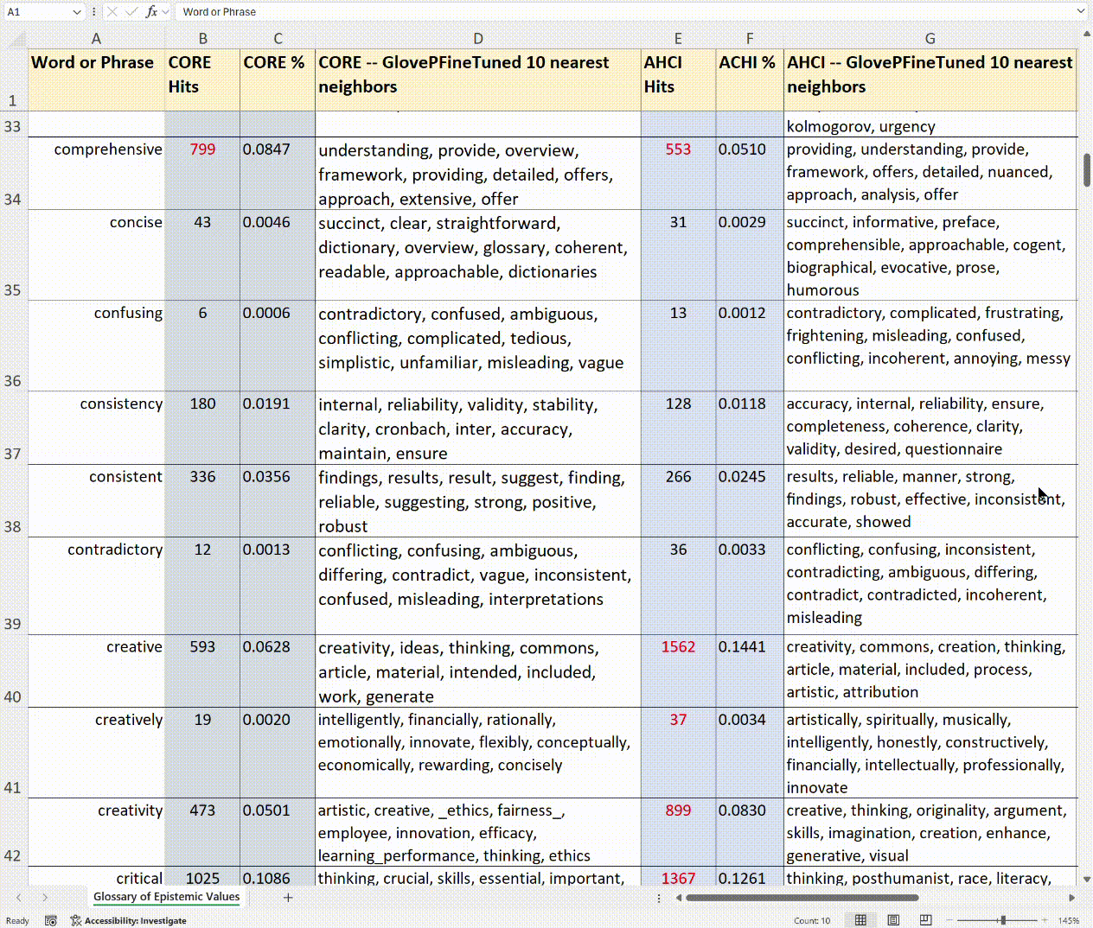
Screenshot of spreadsheet (glossary-epistemic-virtues.xlxs) with epistemic value terms (and nearest word-embedding neighbor terms) for both my WoS Core and WoS AHCI corpora

Glossary Visualized as Word Net Graphs
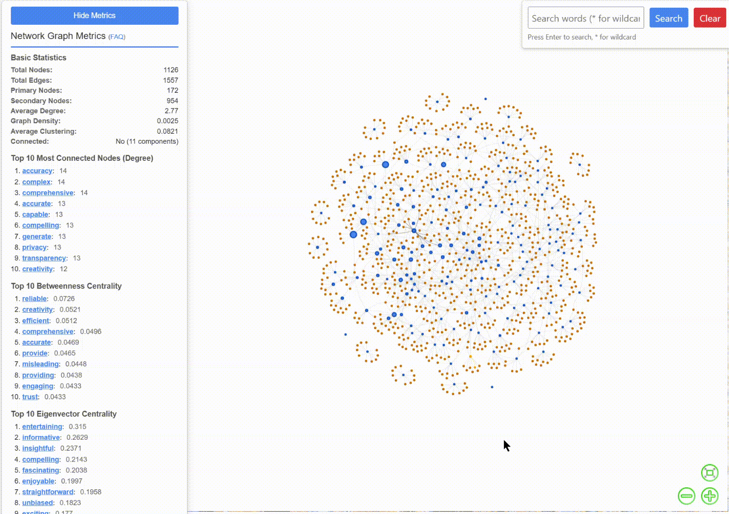
I also used the data in my glossary spreadsheet to build interactive word-net graphs allowing users to explore relations between epistemic values and their word-embedding neighbors for each corpus. Each corpus has its own word net graph. The word-net interface allows users to search for terms, and also shows network metrics. (I used Claude to code the visualization interfaces.)
Screenshot of an interactive word-net visualization of epistemic values and nearest neighbors in my WoS Core corpus, based on the data in my glossary spreadsheet.

How to Use Glossary

I describe the process I followed in using the glossary of epistemic values for interpretive purpose in my article as follows:
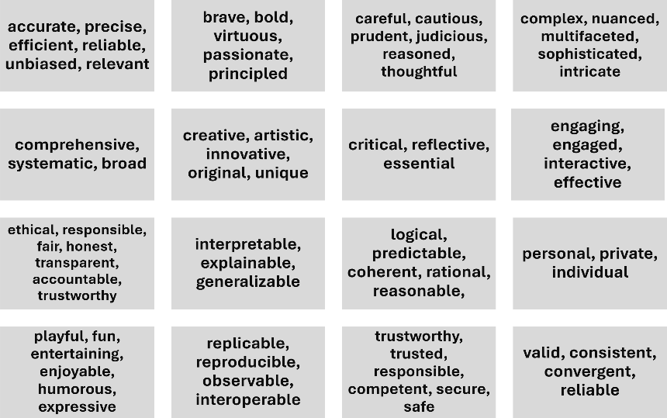
How to use such a kit to observe epistemic values? My practice has been incremental, branching, and iterative. Start anywhere on a word associated with a known epistemic value. I will call such a seed value. Branch out to harvest related epistemic values by looking at ngrams, collocates, and nearest word embedding neighbors. Then repeat, using found values as new seeds. Very rapidly, this builds a word list like the “Glossary” in my kit. Adding to my glossary by making successive passes through the corpora with multiple tools (e.g., Antconc for corpus linguistics study, Mallet for topic modeling, and GloVe for word embedding) can then fill out the terminological map so that a picture emerges not of specific domains and scales but of the larger epistemic system. In the future, linguistic mapping like this can be made more robust through more expert corpus and applied linguistics, “grounded theory” qualitative analysis, controlled vocabularies, and collaboration among domain experts. Eventually, we should be able raise the level of analysis to a meta one where we see grouped assemblages of values—as exampled in figure 4—portraying existing, but likely also evolving, norms.
Figure 2. Example of epistemic values clustered to suggest formations that are functionally norms.

Disclaimer
This is a partial, in-progress glossary. Many more epistemic value terms could be gathered, and future work would likely require culling, consolidating, standardizing, and other editing based on systematic qualitative analysis methods (ideally with a cross-disciplinary team of domain experts).

Works Cited
Anthony, Laurence. AntConc (Version 4.3.1). Waseda University, 29 July 2024, https://www.laurenceanthony.net/software/antconc/.
Barnard, Joel. “What Are Word Embeddings?” IBM, 23 Jan. 2024, https://www.ibm.com/think/topics/word-embeddings.
Heuser, Ryan. “Word Vectors in the Eighteenth Century.” DH 2017 [Montreal], 2017, DH 2017, https://dh2017.adho.org/abstracts/582/582.pdf.
Heuser, Ryan, and Long Le-Khac. A Quantitative Literary History of 2,958 Nineteenth-Century British Novels: The Semantic Cohort Method. Stanford Literary Lab, 2012, https://litlab.stanford.edu/assets/pdf/LiteraryLabPamphlet4.pdf. Stanford Literary Lab Pamphlets 4.
Liu, Alan. “AI Virtue: What Is Good Knowledge in the Age of Artificial Intelligence?” Modern Fiction Studies, forthcoming.
Mccallum, Andrew Kachites. “Mallet: MAchine Learning for LanguagE Toolkit.” Mallet, 2002, http://mallet.cs.umass.edu.
Pennington, Jeffrey, et al. “GloVe: Global Vectors for Word Representation.” Stanford Natural Language Processing Group, Aug. 2014, https://nlp.stanford.edu/projects/glove/.
Schmidt, Benjamin M. “Vector Space Models for the Digital Humanities.” Ben’s Bookworm Blog, 25 Oct. 2015, https://bookworm.benschmidt.org/posts/2015-10-25-Word-Embeddings.html.
Zhang, Yan, and Barbara M. Wildemuth. “Qualitative Analysis of Content.” Applications of Social Research Methods to Questions in Information and Library Science, edited by Barbara M. Wildemuth, Libraries Unlimited, 2009, pp. 308–19, https://pages.ischool.utexas.edu/yanz/Content_analysis.pdf.

Cf., the term “seed word” used by Heuser and Le-Khac in their study of “semantic cohorts” in nineteenth-century British fiction.
For readers unfamiliar with word embedding, a good introductory explanation is by Barnard. Introductions written by and for humanities scholars include Schmidt; and Heuser.
On qualitative analysis and grounded theory methods, see Zhang and Wildemuth.

