Kit for Exploring Most-cited Articles on AI Published in 2024 – Folder 3: Word Embedding Models (Readme)
Alan Liu (kit created 2025-08-05; rev. 2026-03-27; kit website; .zip file in Zenodo)

Folder 3 Overview
For both the corpora referred to as “WoS Core” and “WoS AHCI” in my article, “AI Virtue: Epistemic Value and Generative Artificial Intelligence” (Modern Fiction Studies; forthcoming), I created GloVe word embedding models “fine tuned” on the corpus. (For low- and mid-level beginner explanations of word embedding, respectively, see Serrano, and Barnard. For an introductory explanation of “fine-tuning,” see McDowell.)

Folder 3 Contents
Description |  | Primary Items  (Links go to materials on alanyliu.org website. For full kit, with all data, download the .zip file) |  | Tips for the General User
Readme (this file) | - readme_folder_3.docx
Word Embedding:  Interactive visualizations for exploring GloVe word embedding models fine-tuned on my corpora. Interface allows for finding nearest neighbors of words and analogies. | Self-contained Web pages that open locally in a browser (takes a minute to load):  - WoS-CORE-glove_visualization.html  - WoS-ACHI-glove_visualization.html  Each subfolder also contains a separate word_vectors.txt file with the embedding data along with a model_parameters.txt file. |  | The visualizations of word embeddings are fun to explore. They will be gee-whiz for those new to embedding spaces, where words are placed according to mathematically high numbers of relations with other words—all simplified for visualization in 3D. Users can search in the interface for words and their nearest embedding neighbors.  I used Anthropic's Claude AI to code the visualizations of the embedding data.

Interactive Visualizations
To facilitate exploring the word embeddings, I used Claude to code interactive display interfaces (in the form of standalone HTML webpages) that allow a user to search for words and their nearest neighbors in the embedding space.
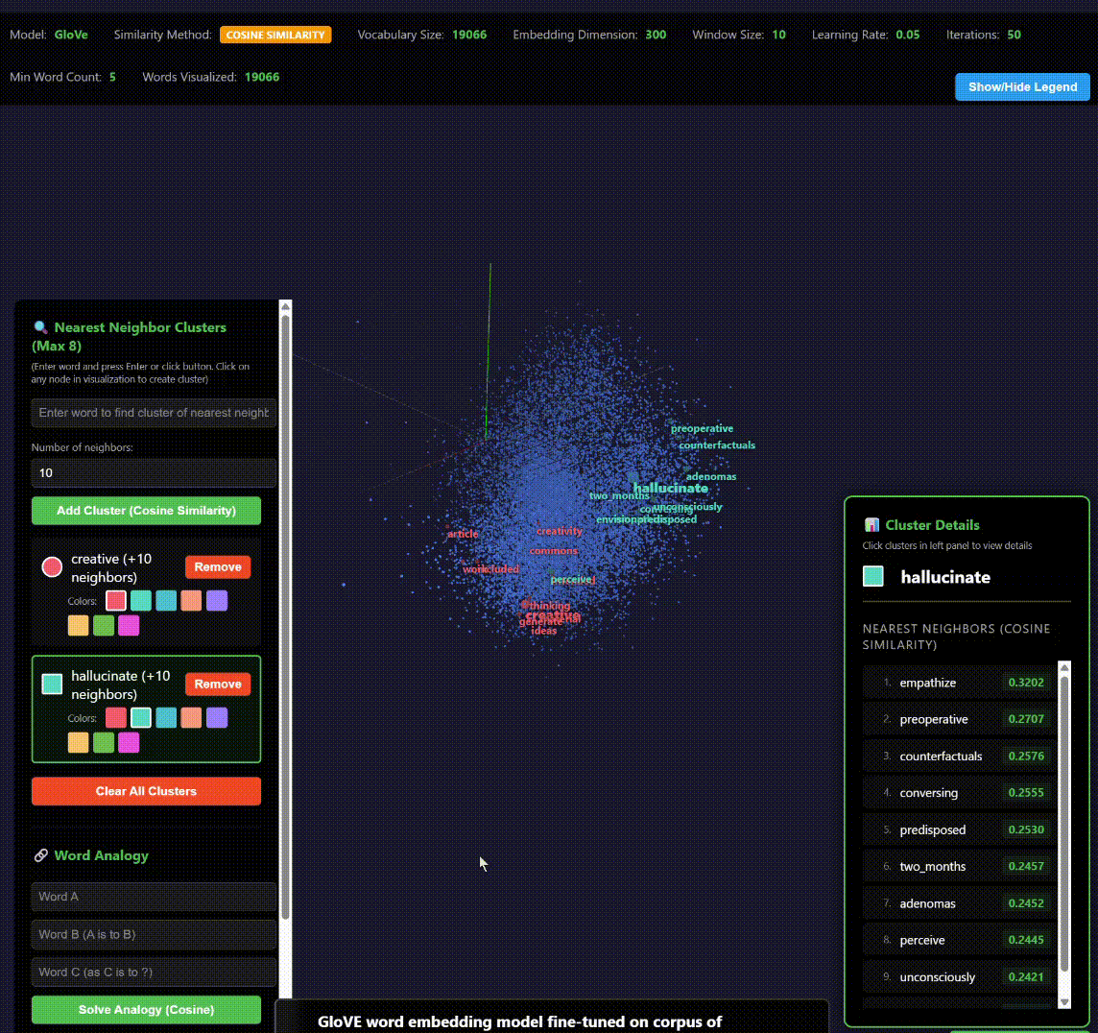
Screen capture of interactive visualization interface for my word embedding models. Users can search for words and their nearest neighbors in the embedding space.

Why GloVE instead of Word2Vec Embedding?
GloVE (Global Vectors for Word Representation) is a word embedding algorithm from the Stanford Natural Language Processing Group that trains word vectors based on “aggregated global word-word co-occurrence statistics from a corpus” (Pennington et al.). As the word global indicates, GloVe is sensitive to the overall context of language in a corpus in learning to embed words in relation others in a high-dimension mathematical space.
By contrast, the word embedding algorithm “word2vec” in the TensorFlow machine-learning framework is more sensitive to the local rather than global context of discourse in a corpus (TensorFlow).
I created both GloVe and word2vec embeddings of my corpora and found that GloVe is clearly preferable for my purposes. Because my corpora are relatively small, and also contain only research articles (often in technical, medical, and similar fields that use specialized technical language), word2vec embeddings were “overfitted” to specialized language. For example, the nearest neighbors of truth in a word2vec model of my WoS core corpus were: ophthalmic, tl, volume, breast, dnn, and ray. (On “overfitting,” see Wikipedia).
I thus chose to use GloVE models to analyze my corpora.

To Fine-Tune or Not?
I first created a pair of GloVe embedding models trained just on my two corpora. Then I created another pair of models by “fine tuning” with my corpora a pretrained GloVe model, “glove.6B.300d.” Glove.6B.300d is based on a vastly larger text collection: the Wikipedia 2014 + Gigaword 5 dataset (Bernhard; Pennington et al.).
To compare the two kinds of models, I sampled in each model the 10 nearest embedding neighbors of words related to some of the epistemic values I was interested in. The models made by fine-tuning the pre-trained GloVe model were clearly better for interpretive purposes. By contrast, the embedding models trained only on my corpora produced nearest neighbors that were “overfitted” to specialized research article language and technical terms. For example, the nearest neighbors of true included: false, positives, ground, positive, tn, indicating, xm, multimodal_genai, negative, feature.)
I thus relied on the fine-tuned pre-trained models for my interpretive work (though at times I consulted the overfitted models to corroborate observations).

Works Cited
Barnard, Joel. “What Are Word Embeddings?” IBM, 23 Jan. 2024, https://www.ibm.com/think/topics/word-embeddings.
Bernhard, Liebi. “GloVe 6B Vectors.” Version 1.2, 10 June 2021, Zenodo, https://doi.org/10.5281/zenodo.4925375.
Liu, Alan. “AI Virtue: What Is Good Knowledge in the Age of Artificial Intelligence?” Modern Fiction Studies, forthcoming.
McDowell, Tiffany. “When to Use Embeddings vs. Fine-Tuning in AI Models.” Telnyx Blog, 18 Dec. 2024, https://telnyx.com/resources/embedding-vs-fine-tuning.
Pennington, Jeffrey, et al. “GloVe: Global Vectors for Word Representation.” Stanford Natural Language Processing Group, Aug. 2014, https://nlp.stanford.edu/projects/glove/.
Serrano, Luis. “What Are Word and Sentence Embeddings?” Cohere Blog, 2023, https://txt.cohere.com/sentence-word-embeddings/.
TensorFlow. “Word2vec | Text.” TensorFlow, 19 July 2024, https://www.tensorflow.org/text/tutorials/word2vec.
Wikipedia. “Overfitting.” Wikipedia, 11 Aug. 2025. Wikipedia, https://en.wikipedia.org/w/index.php?title=Overfitting&oldid=1305291387.

