Kit for Exploring Most-cited Articles on AI Published in 2024 – Folder 2: Topic Models (Readme)
Alan Liu (kit created 2025-08-05; rev. 2026-03-27; kit website; .zip file in Zenodo)

Folder 2 Overview
Using the Mallet topic modeling tool (Mccallum), I created topic models of various numbers of topics (ranging from 15 to 50 topics) for the “WoS Core” and “WoS AHCI” corpora of articles on AI that I assembled for my article, “AI Virtue: Epistemic Value and Generative Artificial Intelligence” (Modern Fiction Studies; forthcoming).

Folder 2 Contents
Description | Primary Items  (Links go to materials on alanyliu.org website. For full kit, with all data, download the .zip file) | Tips for the General User
Readme (this file) | - readme_folder_2.docx
Topic Models  Subfolders:  - wos_core_topicmodel_22topics  - wos_ahci_topicmodel_22topics  - wos_ahci_topicmodel_40topics  Each subfolder contains a spreadsheet summarizing a topic model, the Mallet data files for the model, and DFR Browser 2 and pyLDAvis interactive visualizations of the model  See also my “Guide to Using Topic Model Visualizations to Explore Topic Models.” | Mallet data files:  - (in downloadable .zip file for whole kit)  Model summaries— spreadsheets with descriptive topic labels, top keywords, top docs:  - WoS-Core-corpus-22-topic-model-summary-table.xlsx  - WoS-AHCI-corpus-22-topic-model-summary-table.xlsx  - WoS-AHCI-corpus-40-topic-model-summary-table.xlsx  Interactive visualizations made with DFR Browser 2 & pyLDAvis:  - DFR Browser 2  - core22-dfrbrowser2  - ahci22-dfrbrowser2  - ahci40-dfrbrowser2  - pyLDAvis  - core22-pyldavis  - ahci22-pyldavis  - ahci40-pyldavis  - “Guide to Using Topic Model Visualizations to Explore Topic Models” | Model summaries provide mid-level abstractions of the topic model data. They also include descriptive topic labels suggested by AI.  Interactive visualizations provide higher-level abstractions facilitating interpretation. I recommend the DFR Browser 2 visualizations to general users as the most intuitive and full-featured.  DFR Browser 2 is a Python tool by Scott Kleinman that builds on Andrew Goldstone’s original dfr-browser to create interactive presentations of Mallet topic models. ^{Note †}  See “Guide to Topic Model Visualizations” for how-to’s and best practices for DFR Browser and pyLDAvis.

Topic Modeling Details (selected)

○ Preprocessing
In preprocessing my corpora, I consolidated some phrases and names. For example, I changed “artificial intelligence” and “AI” into “artificialintelligence.” For a stopwords list, I used Mallet’s standard stopwords and added words and names gleaned from reviewing the topic_counts.txt files in the Mallet outputs. Stopping out custom words helps prevent “overfitting” my models to the specialized features of journal research discourse—e.g., publishing or scientific language conventions, or recurrent researcher names used for unrelated people (e.g., from nations where large fractions of the population share common surnames).

○ Mallet Commands and Outputs
Each subfolder for a topic model contains the model’s Mallet output data files. I also include a short text document named _model_parameters.txt that reports on the commands and settings I used in running Mallet.

○ Choosing Optimal Models
After evaluating my models with the aid of Mallet’s diagnostics file (diagnostics.xml), I chose an optimal model for each of my WoS Core and WoS AHCI corpora. I did so by balancing between coherence and document entropy scores (and other measures), and also by using LLMs (Claude and ChatGPT) to evaluate the Mallet data and diagnostics files. The LLMs were helpful in bringing to my attention quality issues in my models that I would not have noticed otherwise. The optimal models for my WoS Core and WoS AHCI models that were my final choices both happen to have 22 topics. For the WoS AHCI corpus, however, I also consulted a 40-topic model (included in this kit), which is not as optimal for coherence and document entropy but in my judgement more interpretable due to finer-grained topics.

Higher-Level Abstractions & Visualizations of Topic Models
The data files that are the output of Mallet (and other) topic modeling tools provide relatively low-level views of the data. For example, the topic_keys.txt data file produced by Mallet for my 22-topic model of WoS Core shows that topic 21 in the model has a weight in the corpus of “0.03241,” and that its most frequent words are, in order, energy supply chain production research techniques efficiency management building clsc optimization design industry data network gen-artificialintelligence algorithm algorithms smart problems (followed by an innumerably long tail of words that are less frequent but nevertheless part of the texture, or context, of the topic). In many cases, a human interpreter can scan such top words and intuit the “topic.” In the case of topic 21’s top words, for example, a snap judgement might be that the topic is about energy supply issues for the AI industry. An interpreter would then normally next peruse some of the top documents associated with topic 21 to confirm or revise that impression. However, there are enough other possible tangents of “aboutness” teased by topic 21’s top words that a human interpreter would also want to ask whether a different, secondary, or nested topic is also important: one that concerns how current large language model AIs use algorithmic brute-force methods that are computationally, and not just physically, inefficient (pointing to AI system optimization topics that are one of the important areas of computer science research).
As the example here of topic 21 in the 22-topic model of WoS Core shows, therefore, It is important that topic models are accompanied by a stepped ladder of higher-level abstractions of their data allowing human interpreters to gain a better understanding of their “aboutness.”
My kit contains tools that allow users to approach the topic models at two levels of higher abstraction:

○ Model Summaries (mid-level abstraction)
For each model, I include a “model summary” in the form of a spreadsheet with descriptive topic labels, most frequent words in a topic, and a list of the five articles most associated with that topic.
In regard to the topic labels: since it can be impressionistic to use short labels to describe topics that, at root, consist just of frequency distributions of words, I used AI as a labeling aid. I first asked AI (ChatGPT 4o) to suggest labels (and short descriptions) on the basis of the most frequent 25 words in each topic and the titles of the five articles most statistically associated with that topic. Then I edited some of the resulting topic labels after looking more closely at words and top articles. In my judgement, this process yields better results in topic labeling than just “eyeballing” the data to come up with labels. This is especially the case if the AIs are given some clear labeling rules, such as “no verbs in labels.” (This particular rule is designed avoid forcing topics into the form of propositional arguments such as a label like: “AI is/is not ethical.” The nature of the data in topic models, which in this example might only show that AI is related to ethics, cannot support the kind of propositions about topics that human interpreters often wish to project on the data.)
○ Model Visualizations (higher-level abstraction)
For each model, I also include:
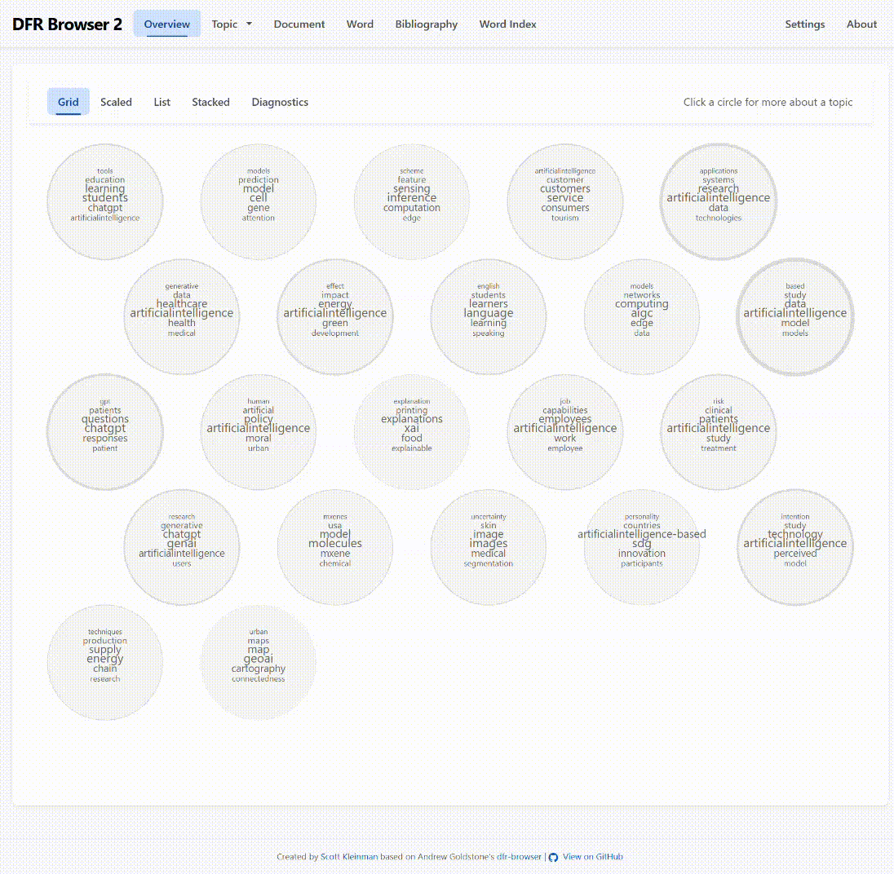
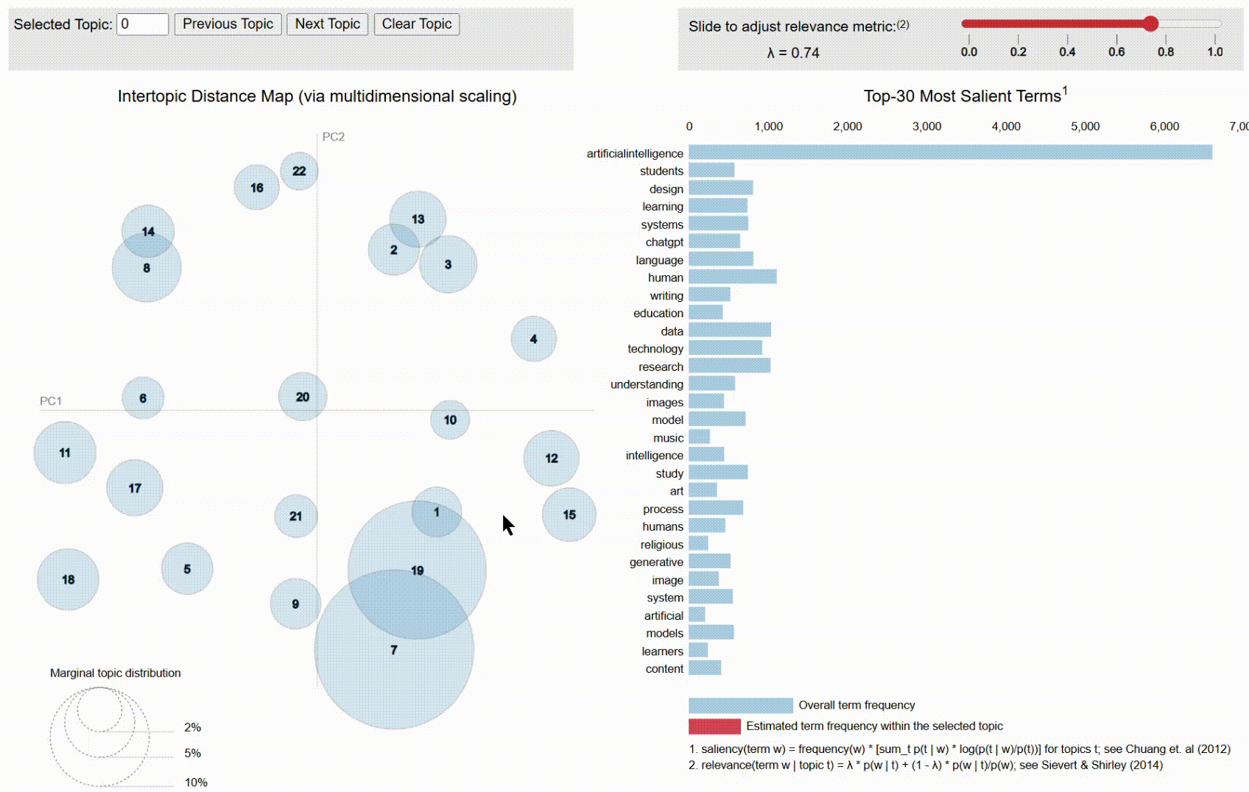
- a DFR Browser 2 visualization (Kleinman) of the model in the form of a folder of resources with an index.html file that must be run in a browser either in a “local server” on a user’s computer or on an online web server. (For instructions on starting a “local server” on a computer see note below.)
DFR Browser 2 view of one of topic model
- a pyLDAvis (Mabey) visualization of the model in the form of a standalone pyLDAvis-visualzation.html file that can be opened on the user’s computer in a browser.
pyLDAvis view of one of my topic models

For help with the interfaces of the visualizations and best practices for using them for interpretation, see the “Guide to Using Topic Model Visualizations to Explore Topic Models” document included in folder 2.

Notes
† (← back)
My thanks to Scott Kleinman for early access to his DFR Browser 2, and for making the DFR Browser 2 visualizations of the topic models in my kit. These visualizations may be opened in a browser from my website through the links in this kit. But for users downloading my kit from its permanent, full-data deposit as a .zip file who wish to run the DFR Browser 2 visualizations locally on their computer, the procedure is as follows (requires the ability to run the Python script included here with DFR Browser 2, or to use other means in a command-prompt window, to start a local web server [localhost] on a computer):
- Open bash on a Mac, or a command prompt, Powershell, or other command terminal in Windows that has access to Python.
- Navigate to the folder containing the index.html file of the DFR Browser 2 view of the desired topic model. (“cd [path to folder]”)
- Run: “python server.py” to start a local web server (the server.py script is included in the folder)
- Open a browser to “localhost:8000”, which will show the DFR Browser 2 visualization running in the local web server.
Alternatively, users can upload the DFR Browser 2 folders in my kit to an online web server (e.g., to their own website).

Works Cited
Kleinman, Scott. DFR Browser 2. 16 Oct. 2025, JavaScript, HTML, Python. 2026, GitHub, https://github.com/scottkleinman/dfr-browser2.
Liu, Alan. “AI Virtue: What Is Good Knowledge in the Age of Artificial Intelligence?” Modern Fiction Studies, forthcoming.
Mabey, Ben. “pyLDAvis 3.4.1 (Python Port of R Package by Carson Sievert and Kenny Shirley).” PyPi, 23 Apr. 2023, https://pypi.org/project/pyLDAvis/.
Mccallum, Andrew Kachites. “Mallet: MAchine Learning for LanguagE Toolkit.” Mallet, 2002, http://mallet.cs.umass.edu.

