Guide to Using Topic Model Visualizations to Explore Topic Models
Alan Liu, last revised March 21, 2026
This document is part of Folder 2 (topic models) in Alan Liu’s “Kit for Exploring Articles on AI Published in 2024”--a digital kit for exploring 553 journal articles published in English in 2024 that mention “artificial intelligence” or “AI” in their titles. The kit accompanies Liu’s article “AI Virtue: What is Good Knowledge in the Age of Artificial Intelligence?,” Modern Fiction Studies (forthcoming).

Folder 2 Overview
The topic models created for this kit (using the Mallet tool for one standard kind of topic modeling) consist of “topics” that are lists co-occurring frequently in different statistical distributions in corpora and their individual documents; data on the relative weight of a each topic’s words in corpora as wholes and specific documents; and other data and metadata. Topical, thematic, discursive, and other interpretable patterns emerge from correlating such data in ways that humans can interpret meaningfully to augment the “close reading” of particular texts with a “distant reading” of larger patterns in a corpora-scale context.
Folder 2 contains Mallet output data files, as well as model parameters (“model_parametiers.txt” files recording essential instructions to Mallet)) and model diagnostics (“diagnostics.xml” files create by Mallet to assist in evaluating the quality of models).
At a higher level of abstraction, the folder also contains spreadsheets I made to assist in gaining a high-level view of the data with the aid of:
- topic labels (assigned with the aid of AI), along with brief descriptions and tags for topics,
- relative weights of topics in the corpus,
- a list of the most frequent 25 words in topics,
- a list of the top five documents in a corpus most statistically associated with topics,
- and essential model diagnostics.
At an even higher, and more intuitively effective, level of abstraction, the folder additionally contains two kinds of interactive visualizations of each topic model: pyLDAvis and DFR Browser 2.

pyLDAvis
pyLDAvis is now a standard topic-model visualization created using a Python implementation of what was originally an R-based tool (LDAvis). DFR Browser 2 is a visualization created using a recently developed Python implementation and augmentation (with additional features) of what was also originally an R-based tool (dfr-browser).
For a guide to the interface of pyLDAvis and best practices for using the environment to understand a topic model, see the following resource I created for the WhatEvery1Says [WE1S] project: “WE1S Topic Model Observatory Guide: pyLDAvis.”
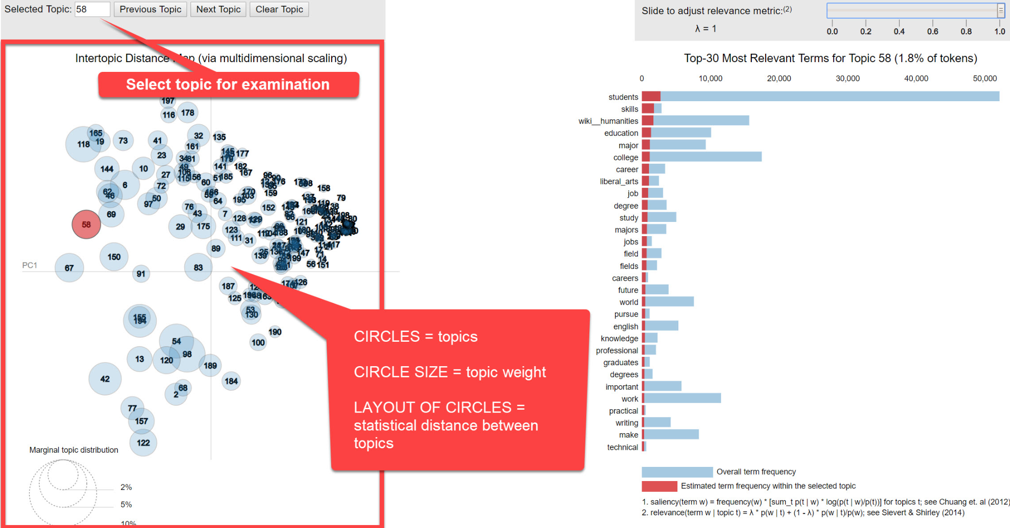
Screenshot from “WE1S Topic Model Observatory Guide: pyLDAvis”

DFR Browser 2
For the general user--and also, in most cases, also for specialists in digital humanities or other digital fields,--DFR Browser 2 is the most intuitive as well as full-featured topic-model visualization environment for exploring topic models. This is an evaluation based on my comparison of the similar original dfr-browser against 13 other topic model visualization systems, and also on using the original dfr-browser extensively with collaborators for the WhatEvery1Says [WE1S] project for which I was principal investigator and Scott Kleiman, the developer of DFR Browser 2, was a co-PI.
For a basic description of DFR Browser 2’s interface, see “Application Views” in Kleinman’s GitHub site for the tool. For more detailed guides to the original, similar dfr-browser with suggestions for best practices in using the interface to read a topic model, see the WE1S Project’s “Topic Model Observatory Guide: Dfr-browser” and the Signs journal’s “An Interactive Topic Model of Signs”: “Getting Started”. (Andrew Goldstone, creator of the original dfr-browser, produced the Signs topic model and its documentation.)
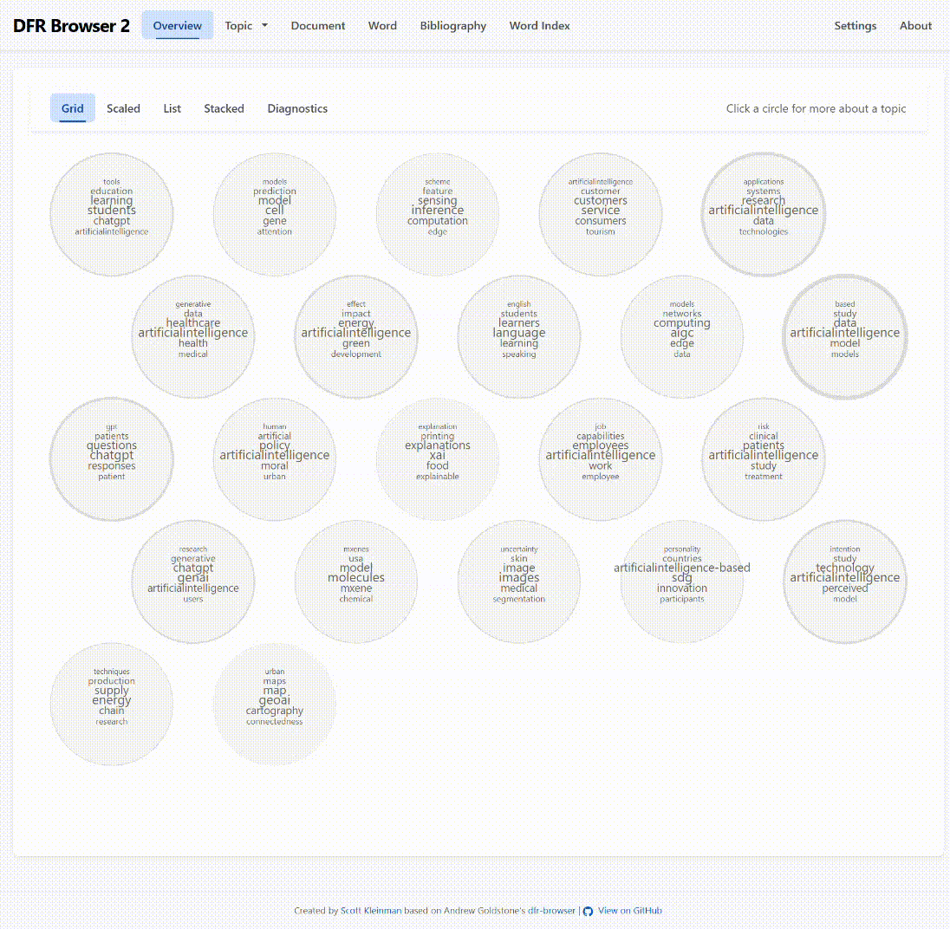
Animated screenshot of a DFR Browser 2 visualization of a topic model in this kit.

